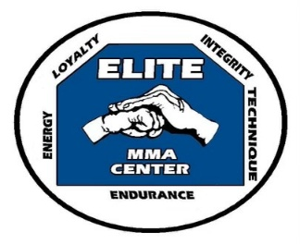Elite M.M.A. Center, L.L.C.  
2022 Main Street, Northampton, PA 18067  
(entrance & parking on Center St. rear of building)  
(Inside Affordable Pet Center)

Presents C.O.R.E.

A Self-Defense Seminar for Adults

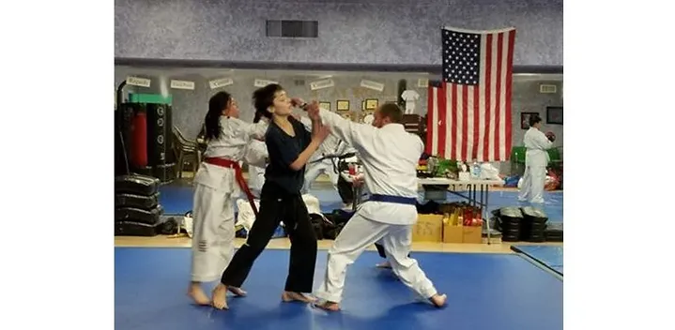**“Spring into Action” by learning how to defend yourself in today’s world! We are offering a 4-week course teaching how to observe your environment and learning proper techniques of punches, kicks & strikes! You will also be taught uncomplicated self-defenses…**

Seminar Cost: $100

**If you have any questions, please call.**

**610 390 3250, 610 392 0065 or 610 392 0408 for**

**more information!**

**“Empower Yourself”**

**Website: elitemmactr.com**

|  |  |  |
| --- | --- | --- |
| Week | Day | Time |
| Week one | March 15th | 3 – 4 PM |
| Week two | March 22nd | 3 – 4 PM |
| Week three | March 29th | 3 – 4 PM |
| Week four | April 5th | 3 – 4 PM |

Bonus: At the end of the program, you will receive a Ku baton (a modern self-defense tool with instruction) for your key chain!